

**YEAR: 8**

**2017**

**SUBJECT: Science**

**TEST: Investigating in Science**

**TIME: 40 minutes**

**QUESTIONS: 10 Multiple Choice (10 marks)**

**4 Short Answer (29 marks)**

**TOTAL MARKS: 39 marks**

1. **SECTION ONE—MULTIPLE CHOICE (10 marks)**
2. This section has **10** questions. Answer **all** questions on the separate Multiple-choice Answer Sheet provided.
3. _________
4. 1) Maddie measured how far an elastic band stretched when masses were hung from it. Throughout the experiment she made sure she always used the same make and thickness of elastic band.
5. From this information, which of the following is the variable that she is changing (the independent variable)?
6. **A** How far an elastic band stretches.
7. **B** The make of elastic band.
8. **C** The masses hung from the elastic band.
9. **D** The thickness of the elastic band.
10. 2) Controlled variables are factors that are kept the same throughout the experiment. From the experiment in Q1, Maddie’s controlled variables were:
11. **A** The stretch of the elastic band and the masses hung from it.
12. **B** The stretch of the elastic band and its make.
13. **C** The make of elastic band and its thickness.
14. **D** The masses hung from the elastic band and its make.

3) Amy ran an experiment in which her aim was: ‘To find out which flowed faster, water or honey’*.* Which of the following is the best conclusion for her experiment?

1. A Honey is really tasty.
2. B Honey is sweet and brown in colour.
3. C The experiment was fun and I learnt a lot.

D Water flowed much faster than honey.

1. 4) Which of these graphs best represents the measurements in the table below?

|  |  |  |  |  |  |
| --- | --- | --- | --- | --- | --- |
| Insects | Flies | Mosquitoes | Ants | Grasshoppers | Moths |
| 1. Number | 1. 20 | 10 | 5 | 5 | 1. 2 |

1. 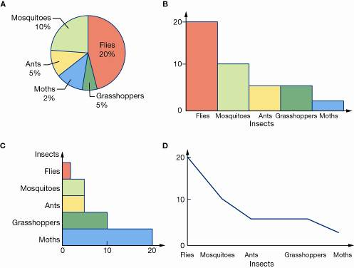
2. **A** graph A
3. **B** graph B
4. **C** graph C
5. **D** graph D

5) The graph below shows information on one effect of smoking on health.

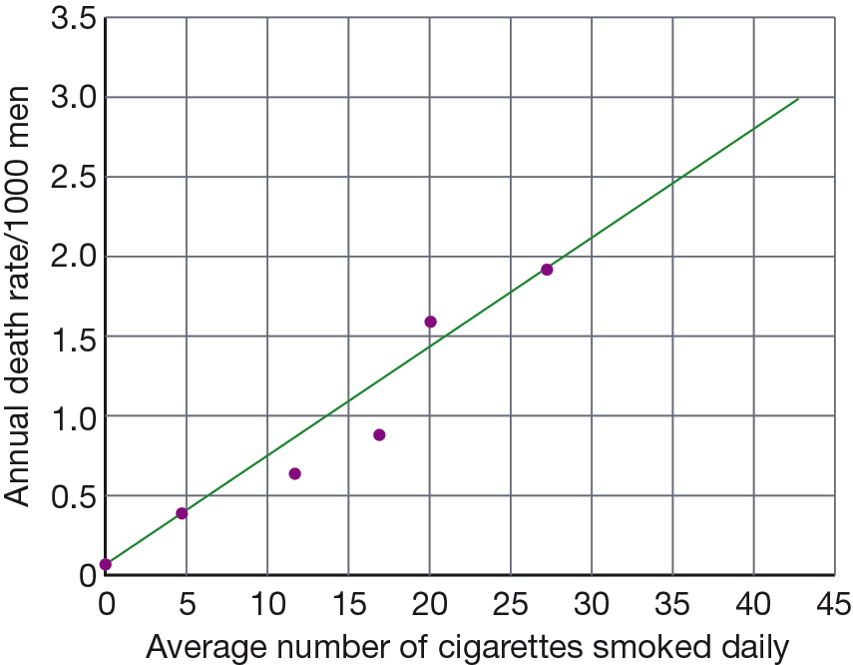

One thousand men smoke 20 cigarettes per day. Use the graph to determine how many are likely to die from lung cancer in one year.

A 1.4

B 2

C 20

D 1000

6) Which of the following statements best describes the link between the number of cigarettes smoked per day and deaths?

A The number of cigarettes smoked does not affect the number of men dying per year from lung cancer.

B The more cigarettes smoked daily, the more men die from lung cancer per year.

C The data obtained in this experiment cannot be trusted because sometimes it predicts that half a man might die.

D Smoking improves your health.

**For questions 7, 8 and 9 read the information below:**

A scientist was trying to see if the amount of water a plant gets affects plant growth. She collected 10 identical plants and gave them different amounts of water. She measured their growth daily. The plants received the same amount of sunlight.

7. What is the **independent** variable?

a) plant growth.

b) amount of sunlight.

c) amount of water.

d) 10 plants.

8. What is the **dependent** variable?

a) amount of sunlight

b) plant growth

c) growth measured daily

d) none of the above

9. What are the **controlled** variable(s)?

a) amount of sunlight

b) 10 identical plants

c) amount of water

d) both A and B

10) Which of the following hazard symbols indicates a TOXIC substance

a)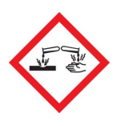 b) 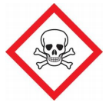

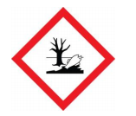 c)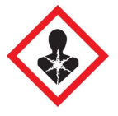d)

1. 
2. **SEMESTER ONE 2017**
3. **Investigating in Science**
4. **ANSWER BOOKLET**
6. **NAME:**
7. **FORM:** **DATE:**
8. Multiple Choice Short Answer Total

**/29**

**/10 (27 marks)**

Answer the questions in the spaces provided.

**/39**

1. **SECTION ONE:** Multiple choice answers
2. Cross (X) through the correct answer.

|  |  |  |  |  |
| --- | --- | --- | --- | --- |
| **1** | a | b | c | d |
| **2** | a | b | c | d |
| **3** | a | b | c | d |
| **4** | a | b | c | d |
| **5** | a | b | c | d |
| **6** | a | b | c | d |
| **7** | a | b | c | d |
| **8** | a | b | c | d |
| **9** | a | b | c | d |
| **10** | a | b | c | d |

1. **SECTION TWO: Short Answer (29 marks)**
2. Answer the questions in the spaces provided.
3. 1) The following statements were written as part of a prac report. **Identify** which statement is the: (5 marks)

**a** Purpose

**b** Hypothesis

**c** Materials

**d** Method

**e** Conclusion.

1. **Statement 1**
2. 100 mL of water was put in a large beaker. 100 mL of cooking oil was slowly dripped onto its surface.
3. This is the ___________________.
4. **Statement 2**
5. If the cooking oil is mixed with the water then it will float on top of water.
6. This is the ___________________.
7. **Statement 3**
8. cooking oil, water, large beaker
9. This is the ___________________.
10. **Statement 4**
11. The oil formed a layer on top of the water.
12. This is the ___________________.
13. **Statement 5**
14. To test if oil floats on water.
15. This is the ___________________.

2) Didier thinks that fertiliser makes plants grow faster. He plants 50 identical seeds in two identical garden beds which are exposed to the same amount of sunlight. He gives both beds the same amount of water and adds fertiliser to one bed only.

**a** Propose a hypothesis for Didier’s experiment. (2marks)

**__________________________________________________________________**

**__________________________________________________________________**

**__________________________________________________________________**

**__________________________________________________________________**

b Identify the variable being tested. (2marks)

**__________________________________________________________________**

**__________________________________________________________________**

**__________________________________________________________________**

**__________________________________________________________________**

c List three controlled variables.(3 marks)

**__________________________________________________________________**

**__________________________________________________________________**

**__________________________________________________________________**

3) Sasha wanted to test how fizzy different brands of orange soft drink were. She set up a test-tube rack and collected four test-tubes. Due to a shortage of equipment, she decided to use three medium-sized test-tubes and one large test-tube. She half-filled the large test tube with a soft drink (D) and timed how long it took for the drink to stop releasing bubbles. She then tested soft drinks A, B and C using the medium test tubes. Her results are shown in the table below. Sasha concluded that soft drink D was the brand that was the fizziest.

|  |  |
| --- | --- |
| Soft drink | Time for fizzing to stop (s) |
| A | 25 |
| B | 47 |
| C | 32 |
| D | 73 |

**a** Sasha did not run a fair test. Explain why.(4marks)

**__________________________________________________________________**

**__________________________________________________________________**

**__________________________________________________________________**

**__________________________________________________________________**

b Discuss whether her conclusion can be trusted.(5 marks)

**__________________________________________________________________**

**__________________________________________________________________**

**__________________________________________________________________**

**__________________________________________________________________**

c Describe a way in which she could improve her method so that her results would be more reliable. (1marks)

**__________________________________________________________________**

**__________________________________________________________________**

**__________________________________________________________________**

**__________________________________________________________________**

4) Sheila noticed that when she put magnesium ribbon into acid, a reaction happened and the acid became hot. She wondered if the rise in temperature had anything to do with the length of the piece of magnesium ribbon that she put in.

She thought she would try to find the answers to this question:-

**When you put magnesium ribbon into acid, does the temperature rise depend on the length of the piece of magnesium ribbon?**

a) Write a suitable hypothesis for this question. (1 mark)

**__________________________________________________________________**

**__________________________________________________________________**

**__________________________________________________________________**

**__________________________________________________________________**

b) Sheila performed an experiment to find the answer to her question and came up with the results below. Calculate the rise in temperature for each and enter in the spaces provided: (2 Marks)

**Starting temperature of acid is 20oC.**

**With 2cm of ribbon the temperature goes up to 25oC.**

**Temperature rise = _____________**

**With 3cm of ribbon the temperature goes up to 28oC.**

**Temperature rise = ______________**

**With 5cm of ribbon the temperature goes up to 33oC.**

**Temperature rise = ______________**

**With 6cm of ribbon the temperature goes up to 35oC.**

**Temperature rise = ______________**

c) In the space below, draw and complete a table to record the ribbon length and the temperature **rise**. (use a sharp pencil and ruler). (4 Marks)

**END OF TEST**

**Please check your work!**